DIGITAL ELECTRONICS
LAB MANUAL

▸ Exp 1A — Basic Gates using NAND Gate (IC 7400) — Separate Circuit for Each Gate
▸ Exp 1B — Basic Gates using NOR Gate (IC 7402) — Separate Circuit for Each Gate
▸ Exp 2 — K-Map: 3-Variable & 4-Variable (Full Calculation + 9 Solved Examples)
▸ Exp 3 — Parity Generator and Checker (IC 7486)
▸ Exp 4 — BCD to Excess-3 (K-Map + Full IC Circuit + IC Count)
▸ Exp 5A — Full Adder (K-Map Derivation + IC 7486/7408/7432 Circuit)
▸ Exp 5B — Full Subtractor (K-Map Derivation + Full IC Circuit)

Md Fazley Rabbi
IC Name & IC Number:

IC Name | IC Number
AND Gate | - 7408: Quad 2-input AND (TTL)
OR Gate | - 7432: Quad 2-input OR (TTL)
NOT Gate (Inverter) | - 7404: Hex Inverter (TTL)
NAND Gate | - 7400: Quad 2-input NAND (TTL)
NOR Gate | - 7402: Quad 2-input NOR (TTL)
XOR Gate | - 7486: Quad 2-input XOR (TTL)
XNOR Gate | - 74266: Quad 2-input XNOR (TTL)

EXPERIMENT 1A: Basic Gates Using NAND Gate (IC 7400)

Theory:
NAND gate: Y = (A·B)' = A' + B' [De Morgan's Theorem]
NAND is called a Universal Gate because every other gate can be built from it alone. This is proven below by constructing NOT, AND, OR, and XOR entirely from NAND gates.

IC 7400 — Quad 2-Input NAND — Full Pin Diagram
IC 7400 is a 14-pin DIP TTL IC containing FOUR independent 2-input NAND gates.

IC 7400 — 7400
Pin 1 — A1 (Gate 1 Input A) | │ | Pin 14 — VCC (+5V)
Pin 2 — B1 (Gate 1 Input B) | │ | Pin 13 — A4 (Gate 4 Input A)
Pin 3 — Y1 (Gate 1 Output) | │ | Pin 12 — B4 (Gate 4 Input B)
Pin 4 — A2 (Gate 2 Input A) | │ | Pin 11 — Y4 (Gate 4 Output)
Pin 5 — B2 (Gate 2 Input B) | │ | Pin 10 — A3 (Gate 3 Input A)
Pin 6 — Y2 (Gate 2 Output) | │ | Pin 9 — B3 (Gate 3 Input B)
Pin 7 — GND (0V) | │ | Pin 8 — Y3 (Gate 3 Output)
Quad 2-input NAND

RULE: Always connect Pin 14 to +5V and Pin 7 to GND before making other connections.

Circuit 1A-1: NOT Gate from NAND (IC 7400)

Formula: Y = A' | NAND gates needed: 1 | IC 7400 needed: 1

Derivation:
Tie both inputs of one NAND gate together:
Y = NAND(A, A) = (A·A)' = A' [since A·A = A by idempotent law]

Truth Table:
A (Input) | Y = A' (Output)
0 | 1
1 | 0

Circuit 1A-2: AND Gate from NAND (IC 7400)

Formula: Y = A·B | NAND gates needed: 2 | IC 7400 needed: 1

Derivation:
Step 1: W = NAND(A,B) = (A·B)'
Step 2: Y = NAND(W,W) = (W·W)' = W' = ((A·B)')' = A·B

Truth Table:
A | B | W = NAND(A,B) | Y = W' = A·B
0 | 0 | 1 | 0
0 | 1 | 1 | 0
1 | 0 | 1 | 0
1 | 1 | 0 | 1
** If Both value are true when it is true, otherwise false. **

Circuit 1A-3: OR Gate from NAND (IC 7400)

Formula: Y = A+B | NAND gates needed: 3 | IC 7400 needed: 1

Derivation (De Morgan's Theorem):
A + B = (A'' + B'') = (A'·B')' [De Morgan's]
Step 1: W1 = NAND(A,A) = A' [Gate 1 as NOT]
Step 2: W2 = NAND(B,B) = B' [Gate 2 as NOT]
Step 3: Y = NAND(W1,W2) = (A'·B')' = A+B [Gate 3]

Truth Table:
A | B | W1=A' | W2=B' | Y = (A'·B')' = A+B
0 | 0 | 1 | 1 | 0
0 | 1 | 1 | 0 | 1
1 | 0 | 0 | 1 | 1
1 | 1 | 0 | 0 | 1

Circuit 1A-4: XOR Gate from NAND (IC 7400)

Formula: Y = A xor B | NAND gates needed: 4 | IC 7400 needed: 1

Derivation (4-NAND minimum XOR): A⊕B=A′B+AB′
X=(AB)′

Y=(A⋅X)′
Z=(B⋅X)′
F=(Y⋅Z)′

X = NAND(A,B)
Y = NAND(A,X)
Z = NAND(B,X)
P = NAND(Y,Z) ← XOR

Truth Table with Intermediate Signals:
A | B | W1=(AB)' | W2=(A·W1)' | W3=(B·W1)' | Y=(W2·W3)'
0 | 0 | 1 | 1 | 1 | 0
0 | 1 | 1 | 1 | 0 | 1
1 | 0 | 1 | 0 | 1 | 1
1 | 1 | 0 | 1 | 1 | 0

Circuit 1A-5: XNOR Gate from NAND (IC 7400)

Formula: Y = (A xor B)' | NAND gates needed: 5 | IC 7400 needed: 2

XNOR = NOT(XOR). Build XOR using 4 NANDs (1 full IC 7400), then add Gate 5 as NOT on XOR output.
Gate 5: Y = NAND(XOR_out, XOR_out) = NOT(A xor B) = A xnor B
Since all 4 gates of IC 7400 #1 are used for XOR, Gate 5 must use a second IC 7400.

X = NAND(A,B)
Y = NAND(A,X)
Z = NAND(B,X)
P = NAND(Y,Z) ← XOR
F = NAND(P,P) ← XNOR
** XOR gate NOT korlei hoye jabe**

Circuits ss:

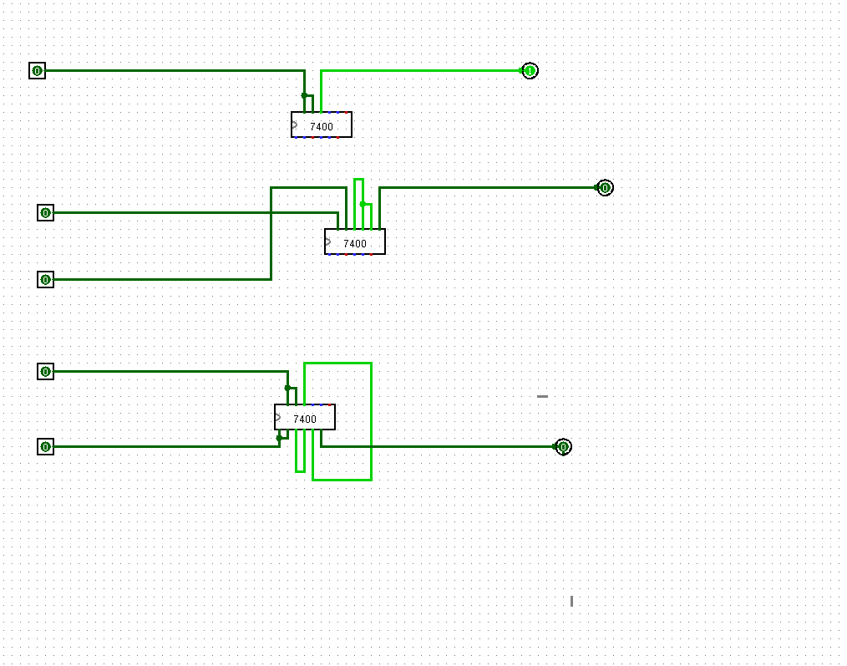

Gate: NOT, AND, OR

EXPERIMENT 1B: Basic Gates Using NOR Gate (IC 7402)

Theory
NOR gate: Y = (A+B)' = A'·B' [De Morgan's Theorem]
NOR is the dual universal gate. Tying inputs gives NOT, chaining two NOR gives OR, three NOR gives AND.

IC 7402 — Quad 2-Input NOR — Full Pin Diagram
IMPORTANT: IC 7402 pin order is REVERSED compared to IC 7400! Output pin comes FIRST per gate.

IC 7402 — 7402
Pin 1 — Y1 (Gate 1 OUTPUT) | │ | Pin 14 — VCC (+5V)
Pin 2 — A1 (Gate 1 Input A) | │ | Pin 13 — Y4 (Gate 4 OUTPUT)
Pin 3 — B1 (Gate 1 Input B) | │ | Pin 12 — A4 (Gate 4 Input A)
Pin 4 — Y2 (Gate 2 OUTPUT) | │ | Pin 11 — B4 (Gate 4 Input B)
Pin 5 — A2 (Gate 2 Input A) | │ | Pin 10 — Y3 (Gate 3 OUTPUT)
Pin 6 — B2 (Gate 2 Input B) | │ | Pin 9 — A3 (Gate 3 Input A)
Pin 7 — GND (0V) | │ | Pin 8 — B3 (Gate 3 Input B)
Quad 2-input NOR
WARNING: IC 7402 Gate 1 -> Output=Pin1, InputA=Pin2, InputB=Pin3 (Output FIRST, then Inputs)

Circuit 1B-1: NOT Gate from NOR (IC 7402)

Formula: Y = A' | NOR gates needed: 1 | IC 7402 needed: 1

Tie both inputs of NOR gate together:
Y = NOR(A,A) = (A+A)' = A' [since A+A = A]

Circuit 1B-2: OR Gate from NOR (IC 7402)

Formula: Y = A+B | NOR gates needed: 2 | IC 7402 needed: 1

Step 1: W = NOR(A,B) = (A+B)'
Step 2: Y = NOR(W,W) = (W+W)' = W' = ((A+B)')' = A+B

Circuit 1B-3: AND Gate from NOR (IC 7402)

Formula: Y = A·B | NOR gates needed: 3 | IC 7402 needed: 1

A·B = (A''·B'') = (A'+B')' [De Morgan's Theorem]
Step 1: W1 = NOR(A,A) = A' [Gate 1 as NOT]
Step 2: W2 = NOR(B,B) = B' [Gate 2 as NOT]
Step 3: Y = NOR(W1,W2) = (A'+B')' = A·B [Gate 3]

Circuit 1B-4: XOR Gate from NOR (IC 7402)

Formula: Y = A xor B | NOR gates needed: 5 | IC 7402 needed: 2

XOR from NOR — 5-gate implementation:
Step 1
$N1=(A+B)^{'}$
Step 2
$N2=(A+N1)^{'}$
Step 3
$N3=(B+N1)^{'}$
Step 4
$N4=(N2+N3)^{'}$
এখানে N4 = XNOR
Step 5
N4 কে invert করো
$XOR=(N4+N4)^{'}$

N1 = NOR(A,B)

N2 = NOR(A,N1)

N3 = NOR(B,N1)

N4 = NOR(N2,N3) ← XNOR

XOR = NOR(N4,N4)
XOR = NOR(N4,N4) Y = NOR(W3, W4) = (A·B'+A'·B)' ... need NOT: Y = NOT(NOR(W3,W4))'
Corrected: Y = NOR(NOR(A',B), NOR(A,B')) using 4 NORs, then NOT = 5th NOR tied to itself

Circuits ss:
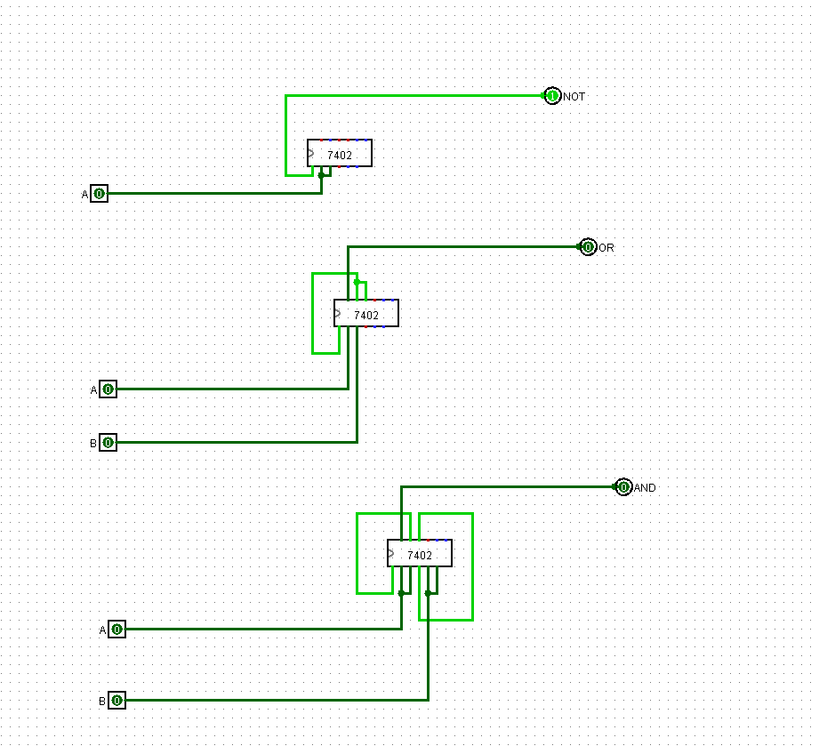

File Link: file
YouTube link: youtube1 Youtube2 Youtube3

EXPERIMENT 2: Circuit from Minterms Using K-Map

Objective
Simplify Boolean functions given as minterm lists using 3-variable and 4-variable K-Maps, then implement with ICs.

2.1 Three-Variable K-Map Theory
Variables: A, B, C | Total cells: 2^3 = 8 | Minterm range: m0 to m7

K-Map Layout (Gray Code columns):
BC
00 01 11 10
┌────┬────┬────┬────┐
A = 0 │ m0 │ m1 │ m3 │ m2 │
├────┼────┼────┼────┤
A = 1 │ m4 │ m5 │ m7 │ m6 │
└────┴────┴────┴────┘

Minterm Table (3-variable):
Minterm | Binary ABC | Expression | Minterm | Binary ABC | Expression
m0 | 000 | A'B'C' | m4 | 100 | AB'C'
m1 | 001 | A'B'C | m5 | 101 | AB'C
m2 | 010 | A'BC' | m6 | 110 | ABC'
m3 | 011 | A'BC | m7 | 111 | ABC

Group Size Rule:
Group Size | Literals Eliminated | Remaining Literals
1 (no grouping) | 0 | 3
2 | 1 | 2
4 | 2 | 1
8 (all cells) | 3 | 0 (F=1)

2.2 Four-Variable K-Map Theory
Variables: A, B, C, D | Total cells: 2^4 = 16 | Minterms: m0 to m15

4-Variable K-Map Layout:
CD
00 01 11 10
┌───────┬───────┬───────┬───────┐
AB=00│ m0 │ m1 │ m3 │ m2 │ A=0, B=0
├───────┼───────┼───────┼───────┤
AB=01│ m4 │ m5 │ m7 │ m6 │ A=0, B=1
├───────┼───────┼───────┼───────┤
AB=11│ m12 │ m13 │ m15 │ m14 │ A=1, B=1
├───────┼───────┼───────┼───────┤
AB=10│ m8 │ m9 │ m11 │ m10 │ A=1, B=0
└───────┴───────┴───────┴───────┘

Complete 4-Variable Minterm Reference:
m# | ABCD | m# | ABCD | m# | ABCD | m# | ABCD
m0 | 0000 | m4 | 0100 | m8 | 1000 | m12 | 1100
m1 | 0001 | m5 | 0101 | m9 | 1001 | m13 | 1101
m2 | 0010 | m6 | 0110 | m10 | 1010 | m14 | 1110
m3 | 0011 | m7 | 0111 | m11 | 1011 | m15 | 1111

Example: use ChatGPT and happy ending

EXPERIMENT 3: Parity Generator and Checker Circuit

Theory
Parity Bit: Extra bit added to data so total count of 1s satisfies a rule.
Even Parity: Total 1s (data + parity) = Even number
Odd Parity: Total 1s (data + parity) = Odd number
XOR property: Result=1 if ODD number of inputs are 1. Perfect for parity!

IC 7486 — Quad 2-Input XOR — Full Pin Diagram

IC 7486 — 7486
Pin 1 — A1 (Gate 1 Input A) | │ | Pin 14 — VCC (+5V)
Pin 2 — B1 (Gate 1 Input B) | │ | Pin 13 — A4 (Gate 4 Input A)
Pin 3 — Y1 (Gate 1 Output) | │ | Pin 12 — B4 (Gate 4 Input B)
Pin 4 — A2 (Gate 2 Input A) | │ | Pin 11 — Y4 (Gate 4 Output)
Pin 5 — B2 (Gate 2 Input B) | │ | Pin 10 — A3 (Gate 3 Input A)
Pin 6 — Y2 (Gate 2 Output) | │ | Pin 9 — B3 (Gate 3 Input B)
Pin 7 — GND (0V) | │ | Pin 8 — Y3 (Gate 3 Output)
Quad 2-input XOR

3-bit Even Parity Generator
Inputs: A, B, C | Output: P = A xor B xor C
Gate 1: W = A xor B (XOR first two bits)
Gate 2: P = W xor C (XOR with third bit)

Truth Table:
A | B | C | 1s Count | W=A xor B | P=W xor C | Transmitted ABCP
0 | 0 | 0 | 0(even) | 0 | 0 | 0000
0 | 0 | 1 | 1(odd) | 0 | 1 | 0011
0 | 1 | 0 | 1(odd) | 1 | 1 | 0101
0 | 1 | 1 | 2(even) | 1 | 0 | 0110
1 | 0 | 0 | 1(odd) | 1 | 1 | 1001
1 | 0 | 1 | 2(even) | 1 | 0 | 1010
1 | 1 | 0 | 2(even) | 0 | 0 | 1100
1 | 1 | 1 | 3(odd) | 0 | 1 | 1111

3-bit Even Parity Checker

Boolean Equation
Error output: $E=A⊕B⊕C⊕P$
Interpretation
- E = 0 → No Error
- E = 1 → Error Detected

Truth Table
A | B | C | P | E
0 | 0 | 0 | 0 | 0
0 | 0 | 0 | 1 | 1
0 | 0 | 1 | 1 | 0
0 | 0 | 1 | 0 | 1
0 | 1 | 0 | 1 | 0
0 | 1 | 0 | 0 | 1
0 | 1 | 1 | 0 | 0
0 | 1 | 1 | 1 | 1
1 | 0 | 0 | 1 | 0
1 | 0 | 0 | 0 | 1
1 | 0 | 1 | 0 | 0
1 | 0 | 1 | 1 | 1
1 | 1 | 0 | 0 | 0
1 | 1 | 0 | 1 | 1
1 | 1 | 1 | 1 | 0
1 | 1 | 1 | 0 | 1

Odd Parity Generator and Checker Circuit

Podd​=(A⊕B⊕C)′
Circuit
- 2টি XOR Gate
- 1টি NOT Gate

Odd Parity Checker
Received bits: A, B, C এবং parity bit P
Checker-এর output E:
$E=A⊕B⊕C⊕P$
Interpretation (Odd Parity)
E | Meaning
1 | No Error
0 | Error Detected
কারণ Odd parity-তে সঠিক data এ মোট 1-এর সংখ্যা odd হবে, তাই XOR-এর ফল 1 হবে।
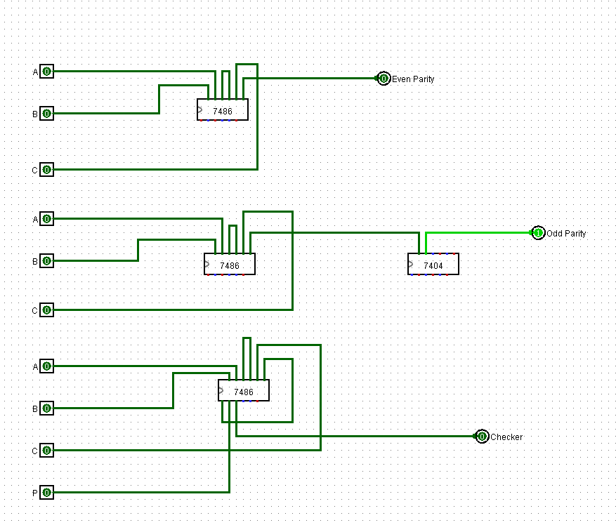

File Link: file

EXPERIMENT 4: BCD to Excess-3 Conversion Circuit

Objective
Convert 4-bit BCD input (A,B,C,D) to Excess-3 output (W,X,Y,Z) using K-Map and standard ICs.

Truth Table — BCD to Excess-3(IC: OR, AND, XOR, NOT)
Dec | A | B | C | D | W | X | Y | Z | Note
0 | 0 | 0 | 0 | 0 | 0 | 0 | 1 | 1 | 0+3=3
1 | 0 | 0 | 0 | 1 | 0 | 1 | 0 | 0 | 1+3=4
2 | 0 | 0 | 1 | 0 | 0 | 1 | 0 | 1 | 2+3=5
3 | 0 | 0 | 1 | 1 | 0 | 1 | 1 | 0 | 3+3=6
4 | 0 | 1 | 0 | 0 | 0 | 1 | 1 | 1 | 4+3=7
5 | 0 | 1 | 0 | 1 | 1 | 0 | 0 | 0 | 5+3=8
6 | 0 | 1 | 1 | 0 | 1 | 0 | 0 | 1 | 6+3=9
7 | 0 | 1 | 1 | 1 | 1 | 0 | 1 | 0 | 7+3=10
8 | 1 | 0 | 0 | 0 | 1 | 0 | 1 | 1 | 8+3=11
9 | 1 | 0 | 0 | 1 | 1 | 1 | 0 | 0 | 9+3=12
10-15 | X | X | X | X | X | X | X | X | Invalid BCD

File Link: file

YouTube link: youtube
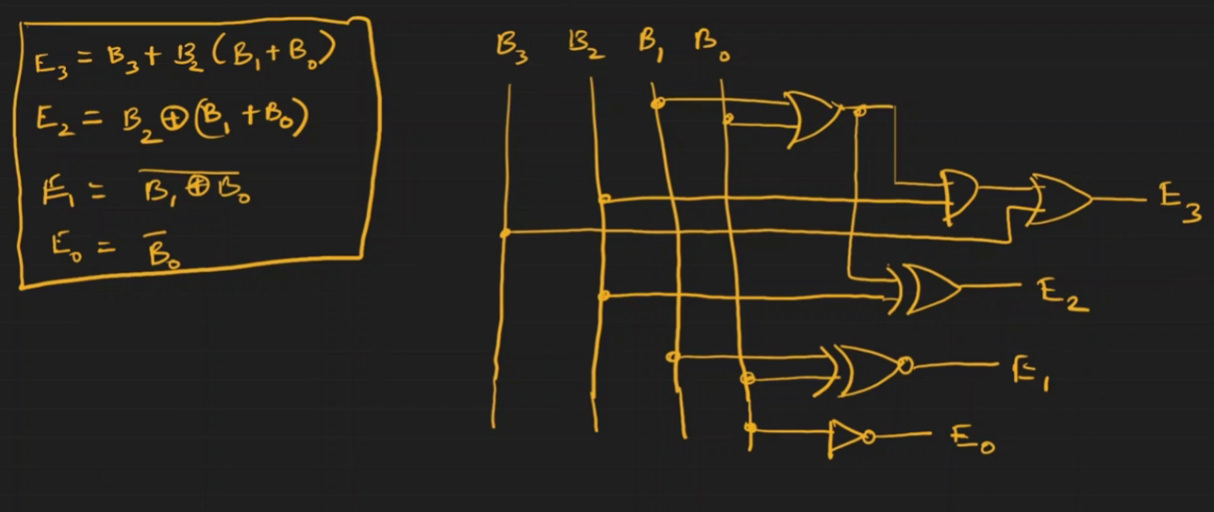
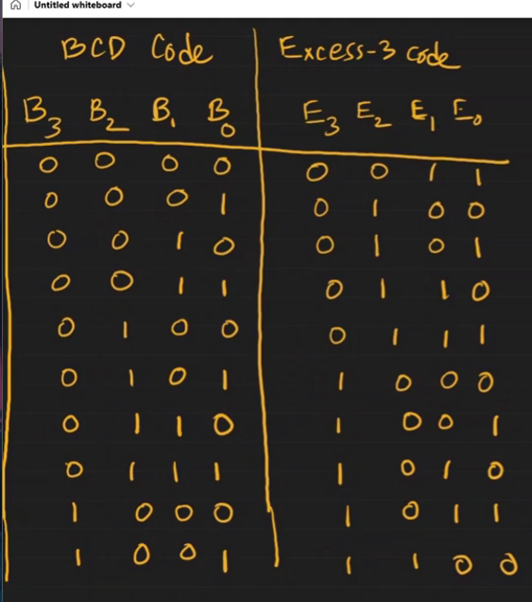
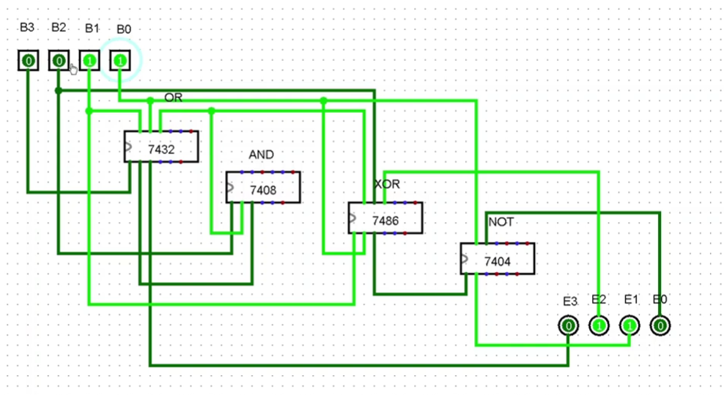

YouTube link: File Link:

EXPERIMENT 5A: Full Adder Implementation

Objective
Design and implement a Full Adder that computes A + B + Cin producing Sum (S) and Carry-out (Cout).

Truth Table
A | B | Cin | Sum S | Carry Cout
0 | 0 | 0 | 0 | 0
0 | 0 | 1 | 1 | 0
0 | 1 | 0 | 1 | 0
0 | 1 | 1 | 0 | 1
1 | 0 | 0 | 1 | 0
1 | 0 | 1 | 0 | 1
1 | 1 | 0 | 0 | 1
1 | 1 | 1 | 1 | 1

Boolean Expressions
🔹 Sum:
$S=A⊕B⊕Cin$
🔹 Carry-out:
$Cout=AB+ACin+BCin$
Alternative form:
$Cout=AB+Cin(A⊕B)$

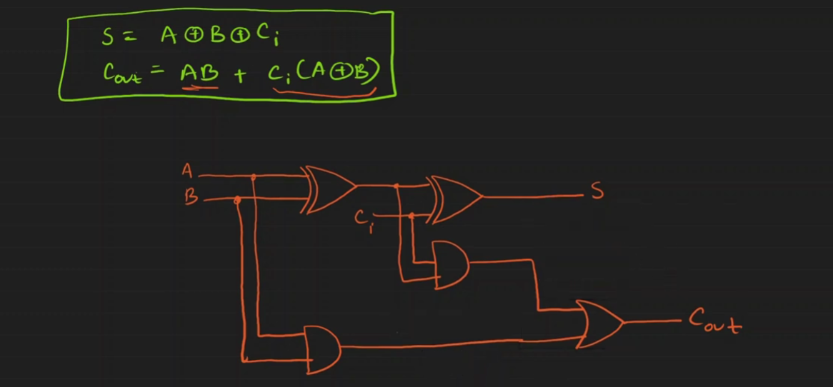

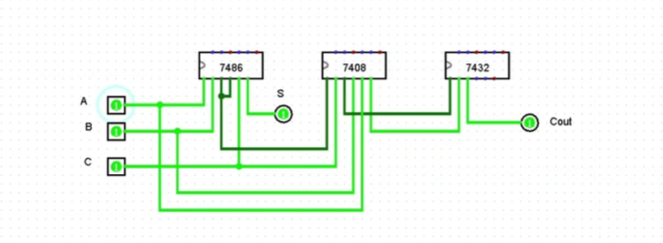

YouTube link: youtube

File Link: file

EXPERIMENT 5B: Full Subtractor Implementation

Objective
Design and implement a Full Subtractor computing A - B - Bin, producing Difference (D) and Borrow-out (Bout).

Truth Table
A | B | Bin | Difference D | Borrow Bout
0 | 0 | 0 | 0 | 0
0 | 0 | 1 | 1 | 1
0 | 1 | 0 | 1 | 1
0 | 1 | 1 | 0 | 1
1 | 0 | 0 | 1 | 0
1 | 0 | 1 | 0 | 0
1 | 1 | 0 | 0 | 0
1 | 1 | 1 | 1 | 1

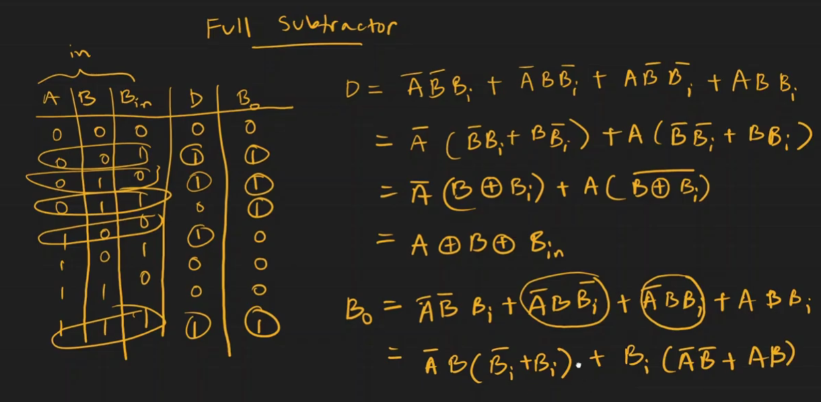

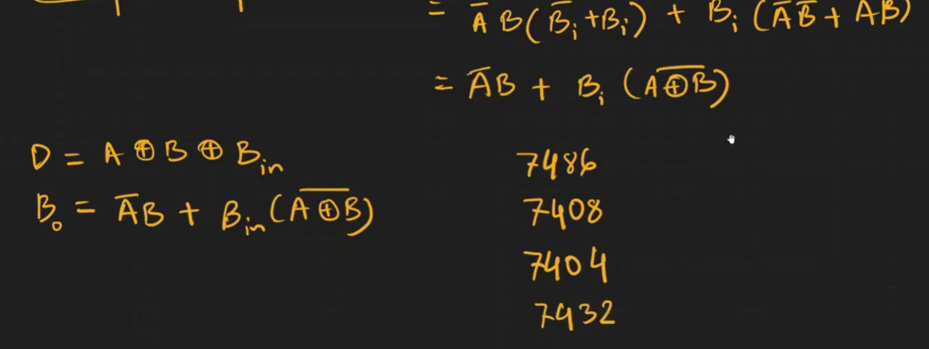

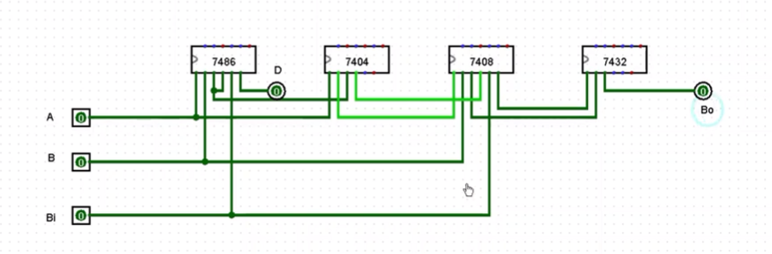

YouTube link: youtube

File Link: file

